Coverage | Up to 4 km
Frequency | 868 MHz (EU), 915 MHz (USA), 2.4 GHz ISM bands (Worldwide)
Data rate | Up to 300 kbps
Latency | 0.02 seconds
Power Efficiency | Less than 2 uA when resting; 8 mA when listening
Scalability | Networks with up to 5,000 devices; 10 Million Endpoints Worldwide
BP35C5-T01 evaluation board specification

Key Features
- Maximum of 1,000 simultaneous connections can be achieved by installing a Wi-SUN FAN stack for
large scale systems in the gateway MCU (20 hops between relays and 64 terminals per relay).
- Mesh networking - A networking in which each station is connected in a mesh. Even if a station fails (network down or radio interference). It is possible to build another route to communicate.
- It covers a wide range because of hopping, and automatic routing can be used to avoid failures.
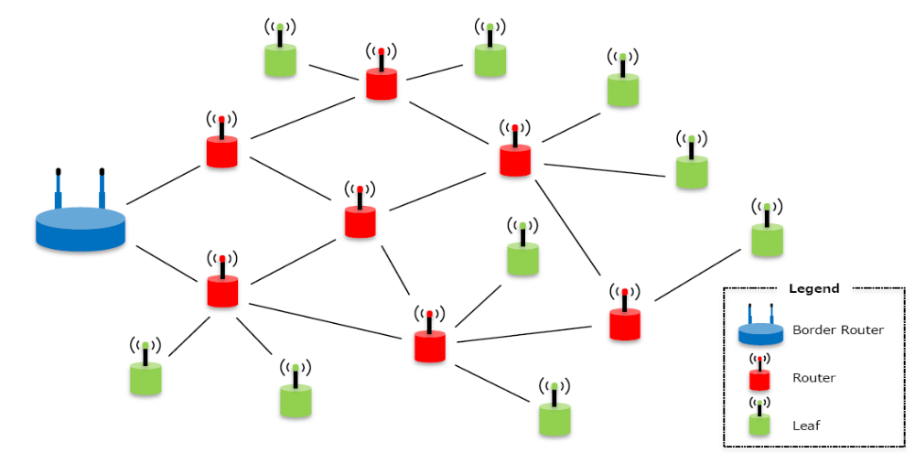
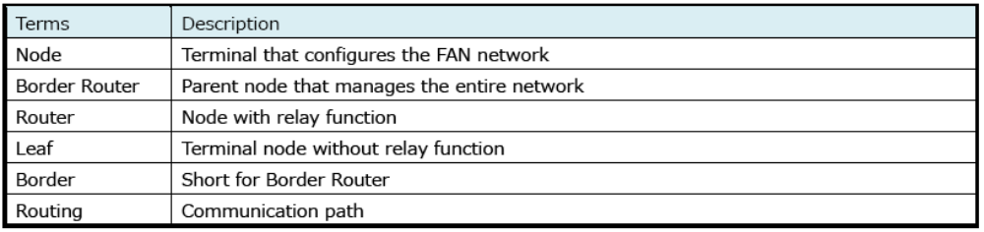

2-UART with RTS & CTS
- UART consists of 2 RX-receive and 2 TX-transmit
- BAUD rate is 115200
- RTS-request to send is an output with Asserted 0V or low & De-asserted 3.3V or high
- CTS-clear to send is an input and is connected to the host’s RTS
- The host is able to tell the module it is available to accept data over the UART by controlling its RTS output which signals to the module via the module CTS input. So the module will not send data unless CTS is asserted. Basically, an asserted RTS output tells the peer that it is safe for the peer to send data. The host can stop the module sending it data by taking its RTS high, which in turn takes the module’s CTS high. Likewise the module can stop the host sending data by taking its RTS high which takes the host’s CTS high.
1-SPI
- MISO- master in slave out
- MOSI- master out slave in
- SCK- SPI clock
- SSN- Slave Select (the "N" identifies it as an active-low signal). Controlled by the master device. An active slave-select line indicates that the master is sending data to or requesting data from the corresponding slave device. MOSI. Data leaves the master device and enters the slave device.
Tera term - Tera term is software that can serially communicate and send binary files.
Tera term supports:
- Serial port connections over UART.
- TCP/IP connections.
- IPv6 communication.
Steps to configuration:-
- Insert BP35C5-T01 evaluation board on top of BP359C
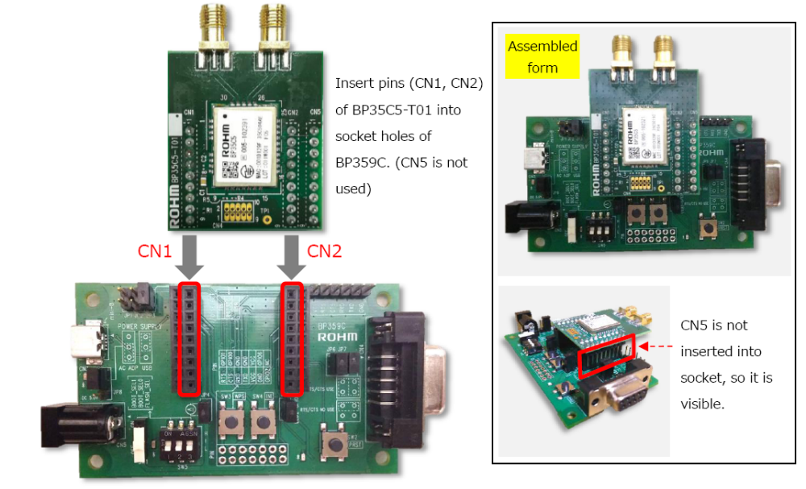

- Connect the hardware to PC via USB cable (mini-B).
When connecting to PC, keep the power switch (SW1) on BP359C off. The evaluation board will be automatically recognized by Windows after connecting.*
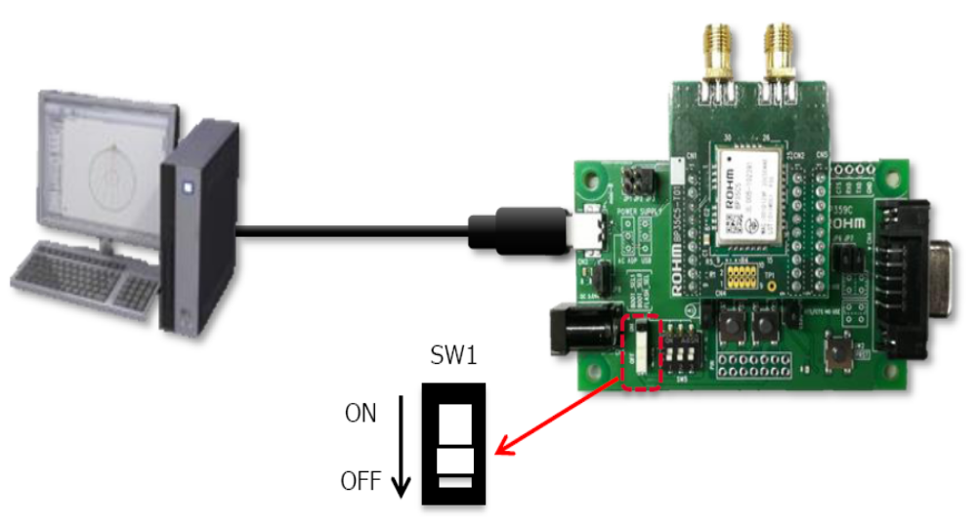

*In BP359C, FTDI is used to convert USB to UART. Windows will automatically install the driver. After installation of driver turn on the power supply in BP359C power switch (SW1). The LED near SW1 will turn green once the power switch is on.
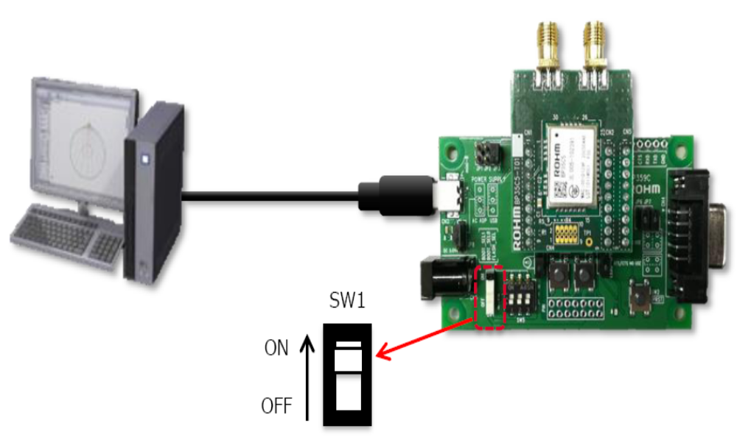

- Download Tera term from https://osdn.net/projects/ttssh2/
Open Tera term
- Select “File” → “New connection”.
Check "Serial" in the displayed window, select COM Port (USB Serial Port) to use, and then click OK. (The COM Port is the number assigned when USB is inserted in PC.)
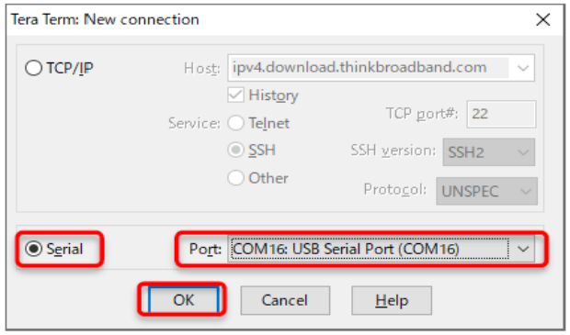

- Select “Setup” in toolbar from dropdown then click on “Serial port”
Select "115200” from the baud rate dropdown in the displayed window.
Set the data to "8bit"
Parity to "none"
Stop bit to "1bit"
Flow control to "none".
Then, click on “New Setting” after selecting.
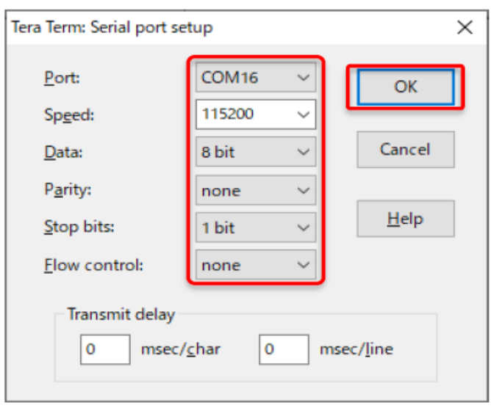

- Select “Setup” in toolbar from dropdown then click on “Terminal”
Under the “Newline” in the displayed window, set both receiving and sending to "CR", and uncheck the Local echo. Then, click OK after selecting.
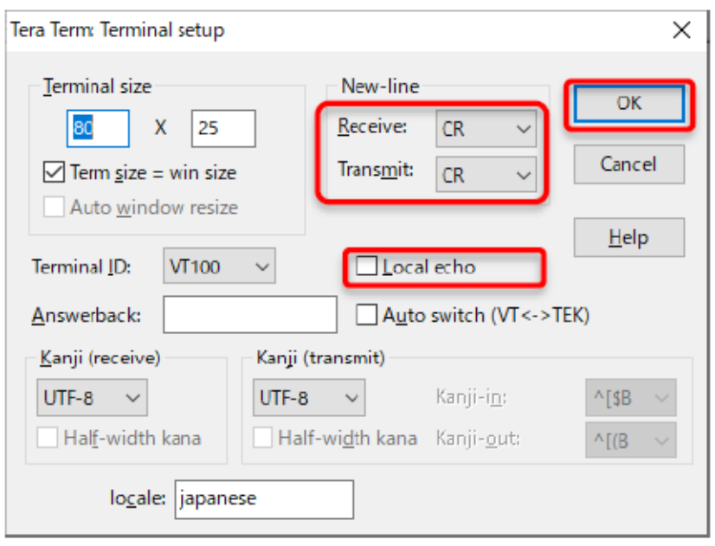

- use "clrst" command to reset the setting to its initial state as show below

The initial BP35C5 state starts as Router. However, it will require a Border unit to configure the network. Thus, set one unit to be a Border.
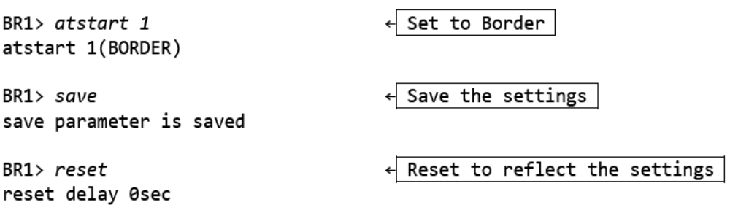

A few moments after setting, the network will be connected as shown below, and an IP address will be automatically assigned to the Router.
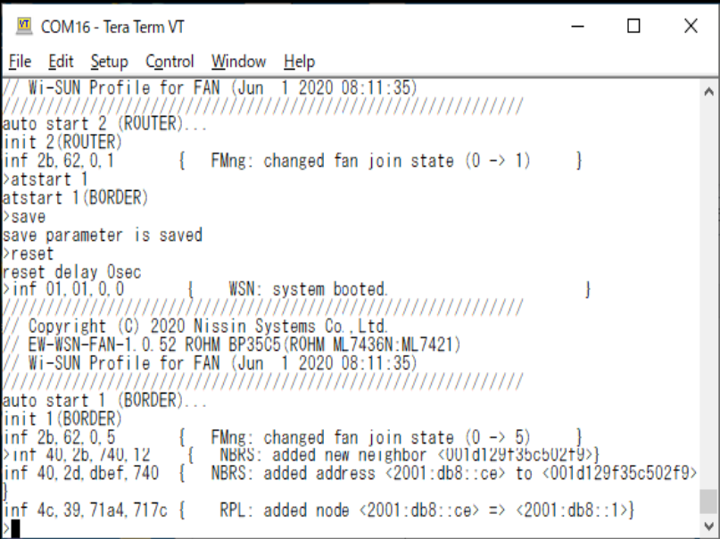

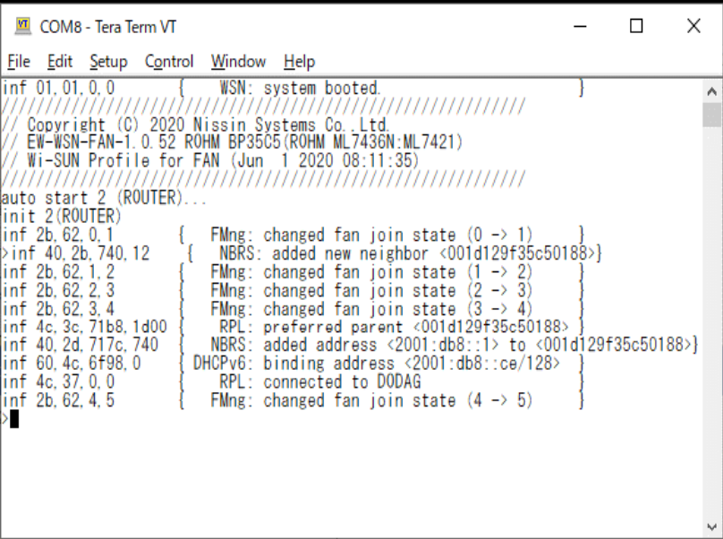
Type "fstat" command to check if the Router is connected to the Border. If "5(OPERATIONAL)" is displayed, then the connection is successful.
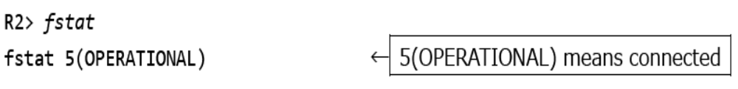

- Verification of communication
Next, run ping from the Border to the Router to verify the communication.
Check the IP address of the Router by sending the "leased" command in the Border.
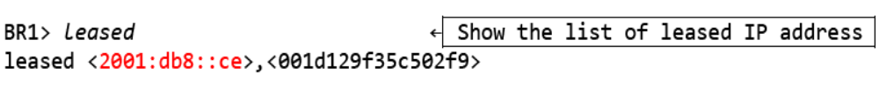
In this example, "2001:db8::ce" is assigned to the Router.
Run ping from the Border.
If the Router responds, it should look like the example below.
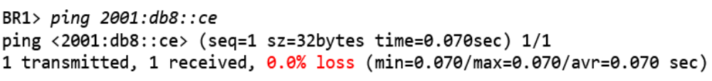

Border (BR1) parameter settings
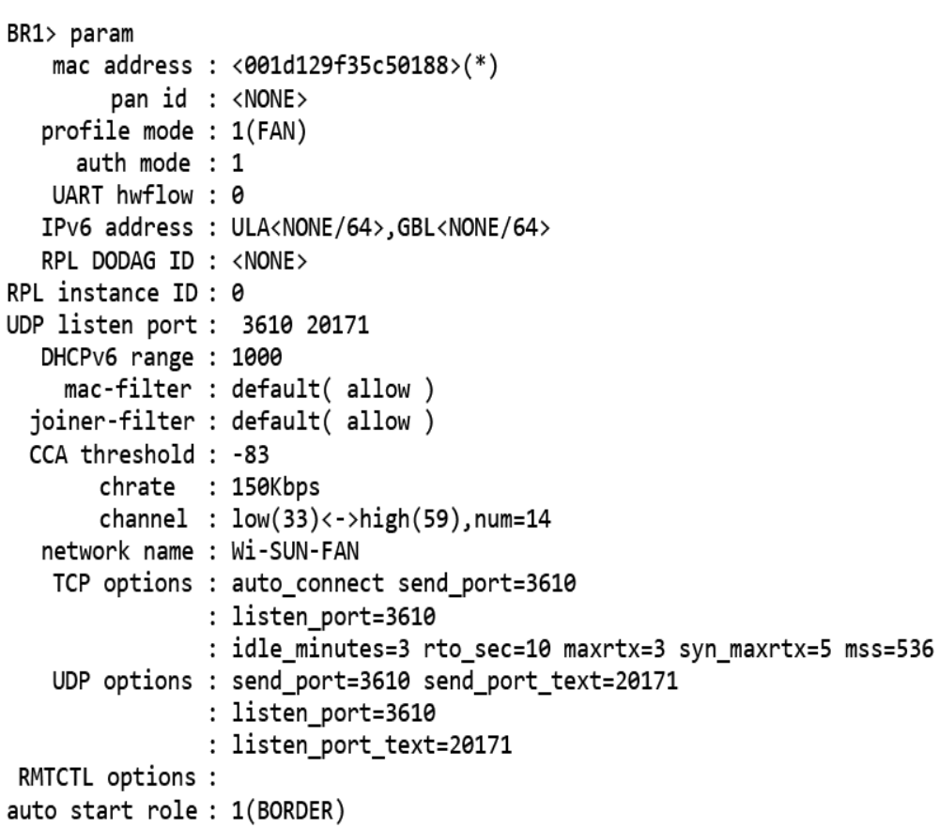

Router (R2) parameter settings
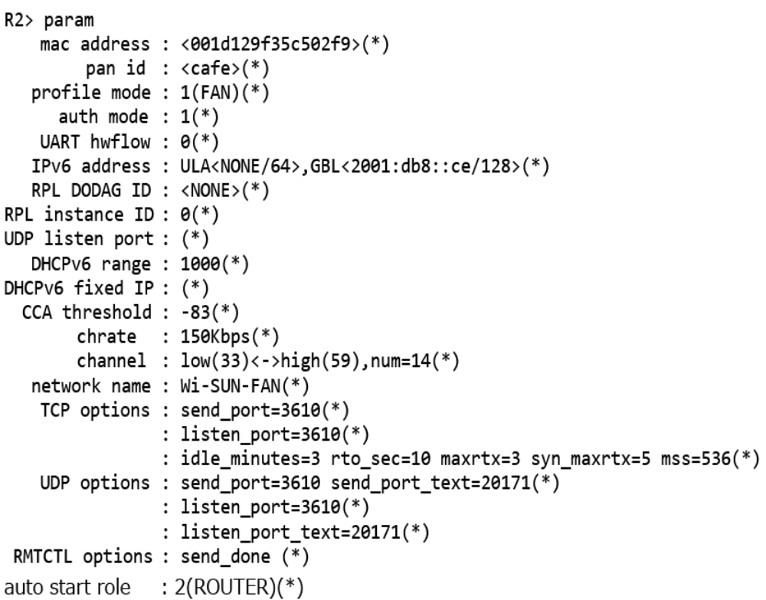

- Updating the firmware
Download Firmware from https://e-support.co-nss.co.jp/
Username: Wi-SUN-FAN
Password: Wi-SUN-FAN-USER

Set the DIP-SW (SW5) of BP359C as follows and reset.
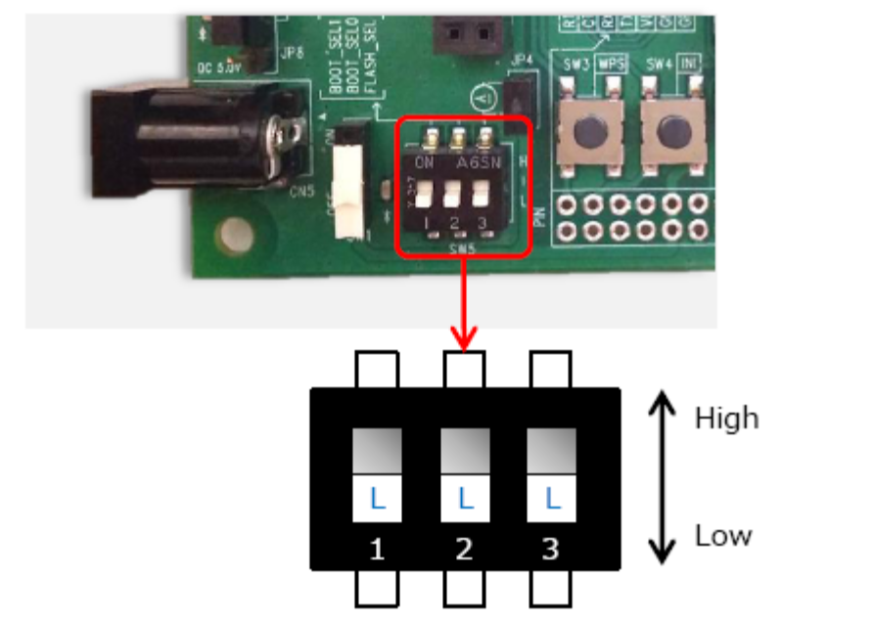

Open the Tera Term.
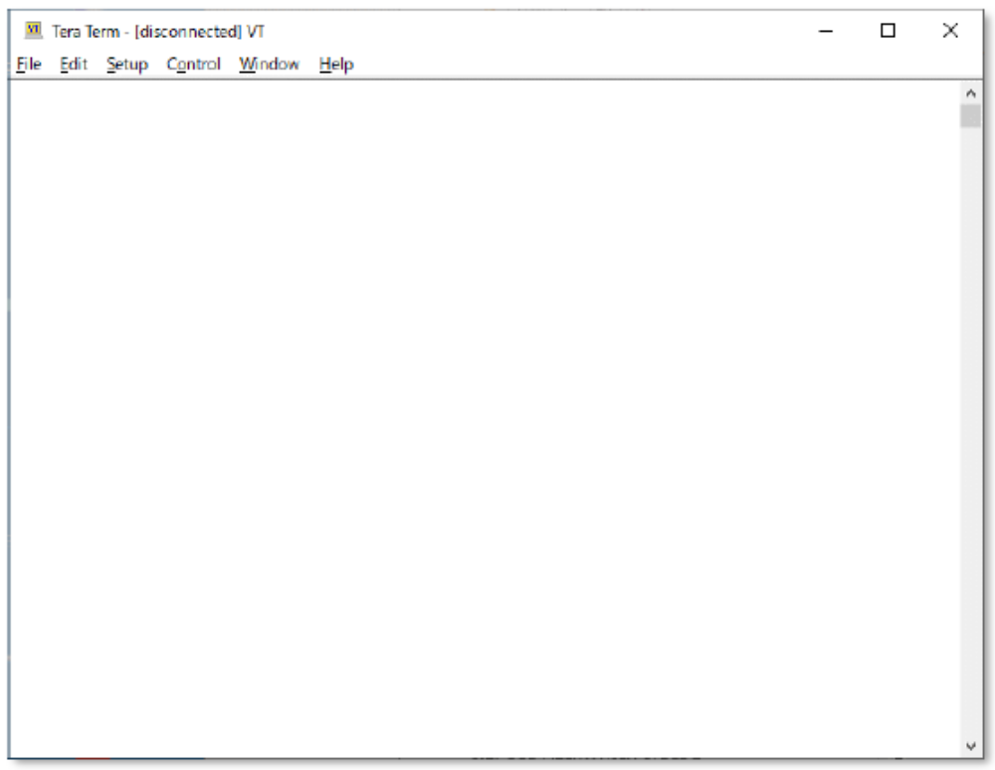

Select [File]-[New connection...] to connect to the BP35C5.
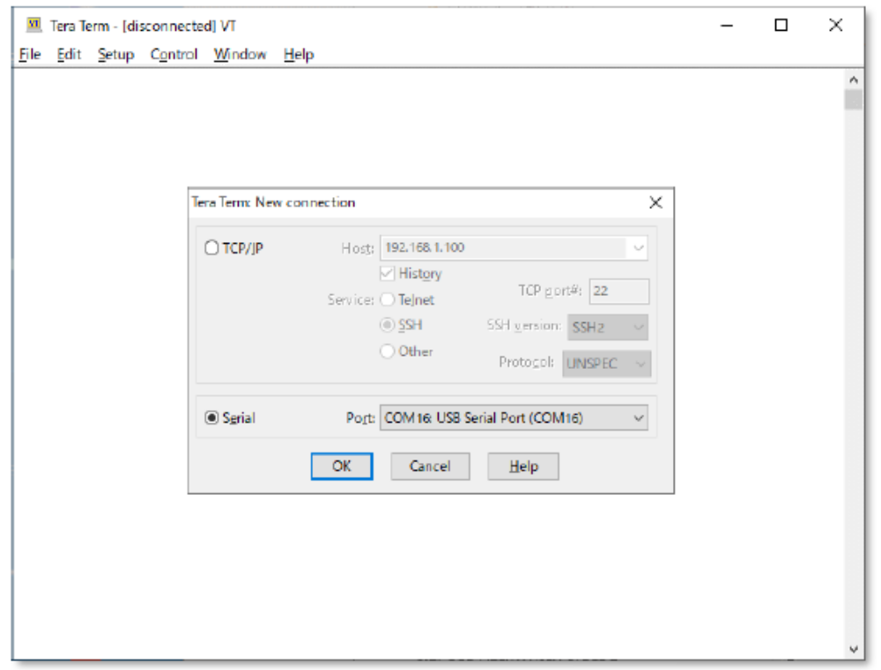
Select [Setup]-[Terminal...] and set as below.
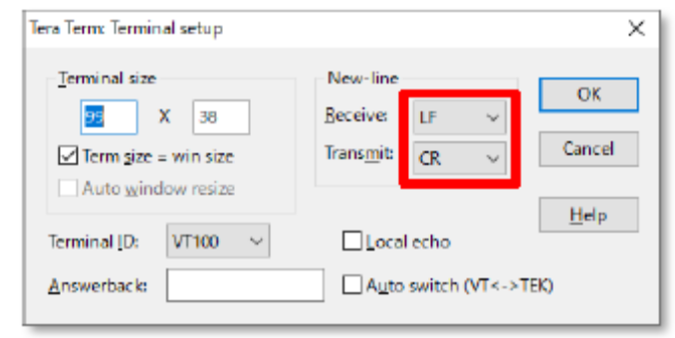
Select [Setup]-[Serial port...] and set as below. And click “new settings”
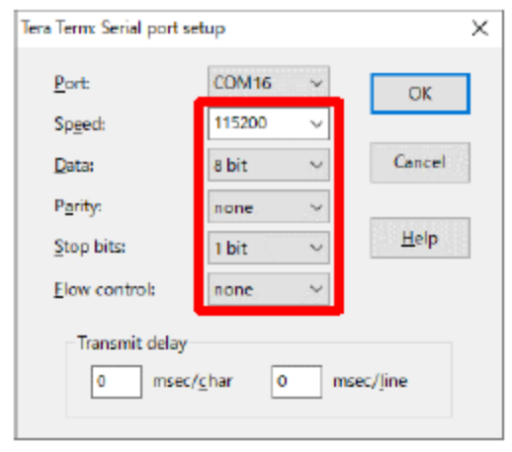
To update the boot loader, select [Control]-[Macro] and select file "bootloader\bootloader.ttl".
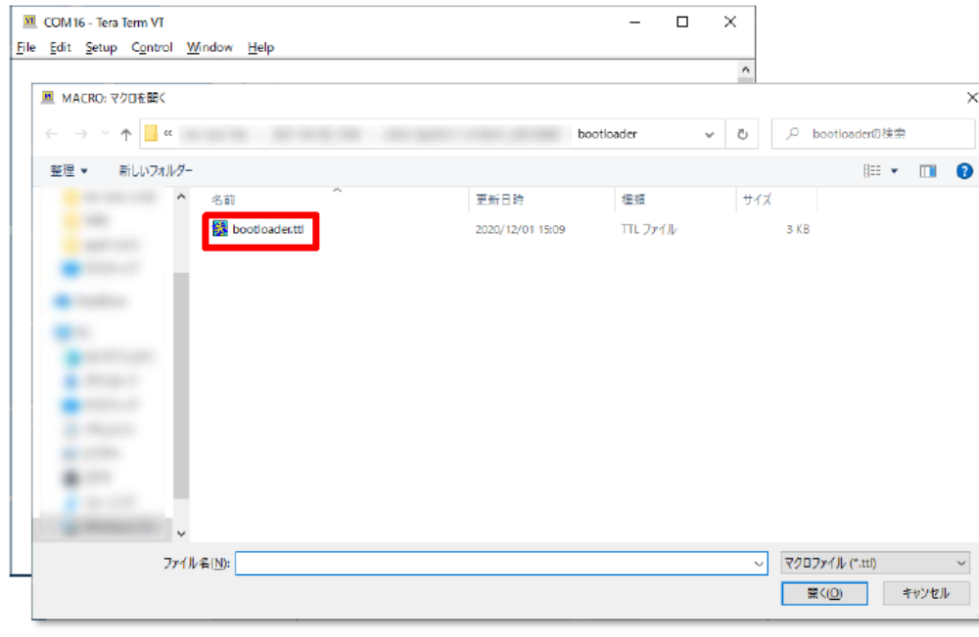The boot loader will be updated.
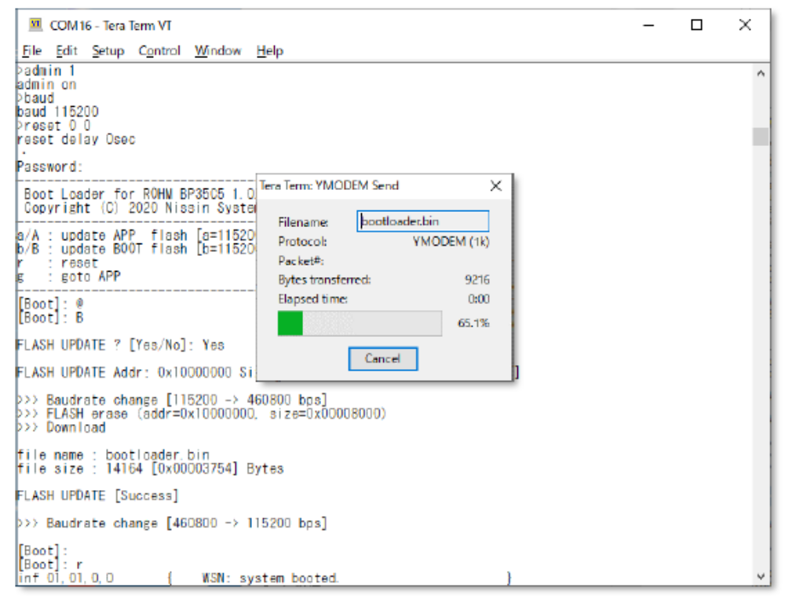
To update the firmware, select [Control]-[Macro] and select file "ew-wsn-cmd\ew-wsn-cmd.ttl".
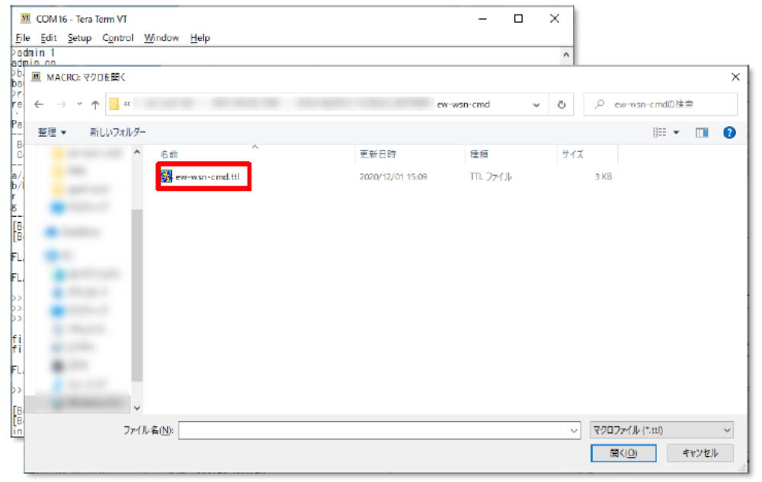
The firmware will be updated.
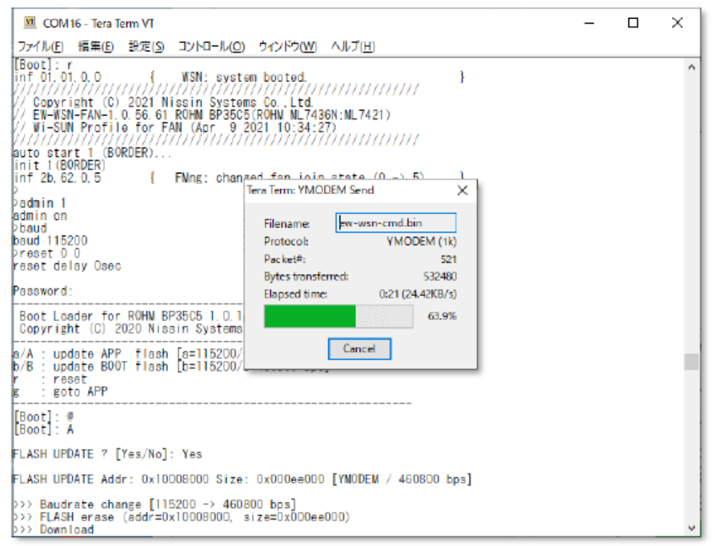
Finally, check for updated version.
